Learning Project WEEK 1
I AM WARRIOR! INVADERS
Age Range: Y5/6
Weekly Maths Tasks (Aim to do 1 per day) |  | Weekly Reading Tasks (Aim to do 1 per day)
- Working on Times Table Rockstars. If your child works on Numbots in school they can access this with the same login.  - Get a piece of paper and ask your child to show everything you know about addition and subtraction. This could be pictures, diagrams, explanations, methods etc. They can be as creative as they want to be.  - Play on Hit the Button - focus on times tables, division facts and squared numbers.  - Daily arithmetic for different areas of maths. Your child should aim to work on level 4, 5 and 6 activities.  - Use the White Rose daily learning challenge. Encourage your child to use PEE (Point – Answer; Evidence – working out, Explain – How do you know this is correct?). https://whiterosemaths.com/homelearning/year-5/  https://whiterosemaths.com/homelearning/year-6/. |  | - Ask your child to read a chapter from their home reading book or a book that they have borrowed from the library.  - Following this, ask your child to summarise the events from the chapter. They could bullet point what happened, create a comic strip or present the information in their own creative way.  - Encourage your child to note down any unfamiliar words from the chapter they have read. Explore the meanings of these words by using a dictionary, reading around the sentence or using print conventions.  - Challenge your child to read something around the house that isn’t a book. They can then complete their reading diary following this.
Weekly Spelling Tasks (Aim to do 1 per day) | Weekly Writing Tasks (Aim to do 1 per day)
- Encourage your child to practise the Year 5/ 6 Common Exception Words (see list)  - Then ask your child to choose 5 Common Exception words. They can then write a synonym, antonym, the meaning and an example of how to use the word in a sentence.  - Practise spellings on Spelling Shed.  - Your child can create a vocabulary bank about their family. They may want to use this for some of their writing tasks this week.  - Get your child to proofread their writing from the day. They can use a dictionary to check the spelling of any words that they found challenging. This will also enable them to check that the meaning of the word is suitable for the sentence.  - Create a Glossary of technical and topic related words. | - Look at a range of images of Roman soldiers and Celtic warriors, discussing how they are similar and different. Use the images to make observations and inferences about each warrior, such as the type of men they were and how they might have fought. Note: Children could compare features such as the warriors’ weapons, armour, footwear and physical appearance.  Useful link: Life as a Roman soldier – BBC Bitesize  - Find out about either the Celtic warriors or the Roman army. Explore how each group was organised, how they fought, their reputations and their armoury.  - Imagine they are either a Celtic or Roman warrior. Draft a short soliloquy entitled ‘I am Warrior’, presenting their thoughts as they prepare for battle. Imagine what they would feel, think and fear. Create a digital mind map to organise their thoughts and ideas. Note: A soliloquy is an act of speaking your thoughts aloud when alone, a device generally used by characters in a play. Begin by modelling a short soliloquy from an unknown warrior and ask the children to guess which side they are on. How can they tell? What clues lie in the soliloquy? What kinds of words and phrases make the account powerful and memorable?  Useful links: Warrior soliloquies
Learning Project - to be done throughout the week
The project this week aims to provide opportunities for your child to understand more about the Roman and Celtic armies, how they fit into British history and how they fought/protected themselves.
- Use a range of historical and online source materials to read, research and organise a timeline showing the chronology of the Roman Empire, from 753 BC to AD 476 with a particular focus on the dates the Romans were in Britain. Work with a partner to sequence significant events, battles, invasions and individuals on their timeline. Note: For each date children could summarise the information found into a short paragraph. Other events and details can be added to the timeline throughout the project. Useful links:
Roman Empire – BBC Bitesize
Roman invasion: The story so far – BBC Hands on History
- Explore patterns and shapes on Celtic and Roman coins by looking at a range of photographic or real examples. Make drawings and sketches of the different patterns and images seen, creating an original design for an ancient coin. Create their coin from a clay slab, rolling, cutting, imprinting and layering to create interesting effects. Decorate their dried coins with gold, silver or bronze paint. Note: Children could create a coin which shows the profile of a Celtic warrior or Roman soldier.
- Look at a range of aerial images showing sites of ancient Celtic hillforts and describe what can be seen. Include descriptions of the shape, site and positioning of ruins including other geographical features nearby, such as woods and rivers. Make a sketch map to show the shape of a ruin and its neighbouring geographical features and explain why the Celts chose to build a fort in that particular spot. Note: Ask the children to explain why the Celts built their forts on hilly sites. How did this help them to defend themselves? How did this make invasion difficult for the Romans? What geographical features of Britain would have hampered the Romans as they invaded?
Life in Celtic Britain – BBC Bitesize
- Design and make a shield for either a Celtic warrior or a scutum (shield) for a Roman soldier. Investigate the materials, shapes and patterns used for each and make sure their design is sturdy and decorative. Work in pairs to evaluate whether their designs would survive a brutal and bloody battle! Note: Children might also make other weapons such as a Roman pilum (throwing spear), a pugio (Roman dagger), cassis (Roman helmet) or Celtic javelins, hammers, axes and swords. Encourage the makers to work safely and avoid any pre-battle injuries!
Celtic and Roman shields

Additional learning resources parents may wish to engage with
Classroom Secrets Learning Packs - These packs are split into different year groups and include activities linked to reading, writing, maths and practical ideas you can do around the home.
Twinkl - to access these resources click on the link and sign up using your own email address and creating your own password. Use the offer code UKTWINKLHELPS.
#TheLearningProjects

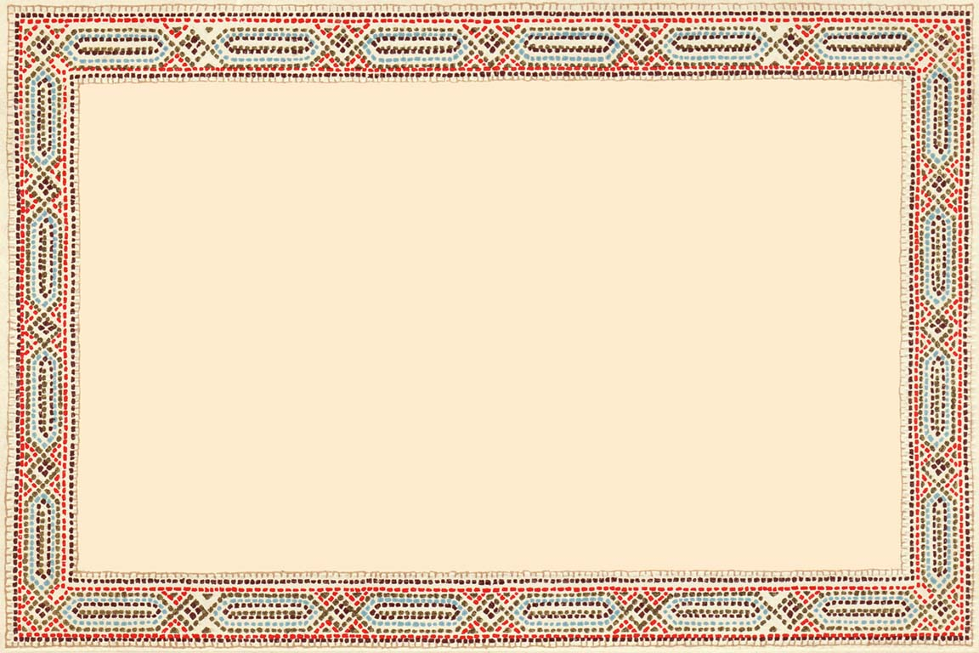
Roman Soliloquy

Characters: ROMAN WARRIOR
Scene: At camp before a battle

A Roman warrior is resting in his tent, preparing for battle in the morning.

ROMAN: Tomorrow, I fight again. So many times I have found myself alone with my thoughts on the eve of battle. It is 20 years since I began my army life. I now have only five more years to serve before I bid farewell to fighting forever. If I survive, I hope to retire to the country. As a veteran soldier, I should receive a fair piece of land.

My prayers have gone to Mars so he may fight on our side and give us his strength and support. I pray we shall destroy the blue-faced barbarians and grind them into the dust beneath our feet!

Am I afraid? I would be a fool to say ‘not at all’. I may die here in this awful place, killed by savages with my head cleaved from my body. How then may the coins be placed in my mouth, to pay the ferryman who will take me to heaven?

Enough of such thoughts. We are better equipped and better disciplined that the Celts, and we have our armour. Tomorrow, this fear will be gone, for then I shall see our standards raised and our eagle held high and proud against the sky. I will be eager for the fight and fall upon the foe like a thunderbolt from Jove himself.

©2017 Cornerstones Education Ltd

Celt Soliloquy

Characters: CELIC WARRIOR
Scene: At camp before battle

A Celtic warrior is sitting by a campfire, sharpening a javelin in preparation for battle.

CELT: I followed my warrior Queen when the call came. When I saw
her, standing brave upon the hillock with her red hair streaming in the wind, I thought to myself, “Here is the leader we need.” She urged us rise up against the strangers in our land: the men who treated her and her family so badly. I have already witnessed great victory and seen Colchester in flames, the blood of the enemy soaking the ground. I have a tattoo of a wolf. May his sharp teeth help me tear and rip with my javelin.

This evening, I offered beef and beer to the woodland spirits, so that the enemy may lose their way through the woods. Offerings, too, were given to the river spirits, that they may drown the enemy in the waters.

Tomorrow, I shall paint my face with woad so my wild eyes will glare and my white teeth will shine out like the wolf. How my enemies will fear my coming!

They will weigh themselves down with armour; we are light and quick. When the ground is open, our chariots will race forward on all sides and break their ranks. We will leap out to fight them, or we’ll hide amongst the trees and surprise them as they pass through!

Their standards and their eagle shall be cast down and trampled in the mud. Their blood shall be washed into the river by the rain and the spirits will thank us for it.

We shall fight like wild creatures of the forest. We shall overcome!

©2017 Cornerstones Education Ltd

